# grep Assignment

1. Use any .c file. Using grep command extract and display
   1. all lines beginning with #include with line numbers
   2. display all lines which do not begin with #include
   3. display the line number of main()
   4. extract all lines containing characters of opening and closing parathesis {(,)}

**Ans: grep -n “^#include” prg.c**

**grep -v “^#include” prg.c**

**grep -n “main()” prg.c**

**grep “[{}()]” prg.c**

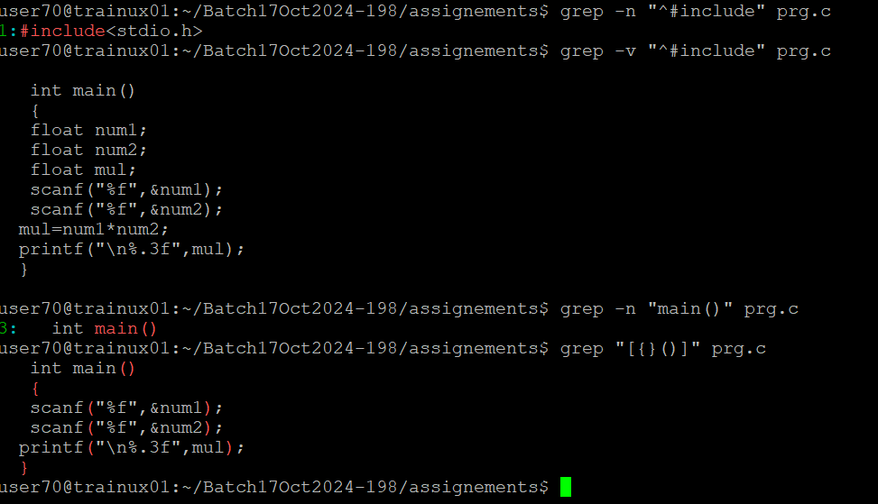

1. Perform the above operations on a set of *.c files

**Ans:** **• grep -n "^#include**

**• grep -v "^#include”**

**• grep -n "main()"**

**• grep "[{}()] "**



